

Worksheet-4: OPP in C++ Part -2

Submitted by – James Limbu (23085133)

Submitted to - Aashish Acharya

Tasks
Task 1: Solve the following programming problems:
1. STL Container Practice: Write a program using STL containers that: (40 marks)
1. Uses vector<string> to store names (5 Marks)
2. Uses map<string, int> to store age against each name (5 Marks)
3. Implements functions to:
1. Add new name-age pair (10 marks)
2. Find all people above certain age (10 marks)
3. Sort and display names alphabetically (10 marks)

Code:
#include <iostream>
#include <vector>
#include <map>
#include <algorithm>
using namespace std;
void addPerson(vector<string>& names, map<string, int>& ages, string name, int age) {
names.push_back(name);
ages[name] = age;
}
void findPeopleAboveAge(map<string, int>& ages, int m_age) {
cout << "\n|||||||||- PEOPLE ABOVE AGE " << m_age << " -|||||||||" << endl;
for (auto person : ages) {
if (person.second > m_age) {
cout << person.first << " (" << person.second << " years old)" << endl;
}
}
}
void displaySortedNames(vector<string> names) {
sort(names.begin(), names.end());
cout << "\n|||||||||- SORTED NAMES -|||||||||" << endl;
for (string name : names) {
cout << name << endl;
}
}
int main() {
vector<string> names;
map<string, int> ages;
char choice;
do {
string name;
int age;
cout << "\nEnter name: ";
cin >> ws;
getline(cin, name);

cout << "Enter age of " << name << ": ";
cin >> age;

addPerson(names, ages, name, age);

cout << "Do you want to add another person? (y/n): ";
cin >> choice;

} while (choice == 'y' || choice == 'Y');

displaySortedNames(names);
int ageLimit;
cout << "\nEnter age to filter people above it: ";
cin >> ageLimit;
findPeopleAboveAge(ages, ageLimit);
return 0;
}

OutPuts:
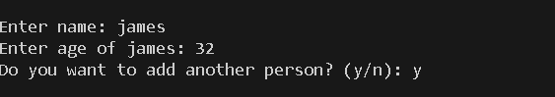
1. Output when user runs the code
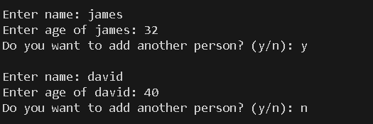
2. output when user wants to add more people and not want to add more people
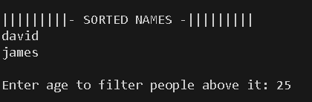
3. Output when user come out of that input. It provides option to filter people age.
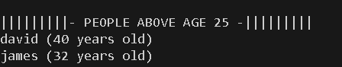
4. People above 25 age according to userinput.

2. Stack Problem: Implement a stack using arrays (not STL) that: (20 marks)
1. Has basic push and pop operations
2. Has a function to find middle element
3. Has a function to reverse only bottom half of stack
4. Maintain stack size of 10
#include <iostream>
using namespace std;
class Stack {
private:
int arr[10];
int top;
public:
Stack() {
top = -1;
}
bool isFull() {
return top == 9;
}
bool isEmpty() {
return top == -1;
}
void push(int value) {
if (isFull()) {
cout << "Stack is full!\n";
} else {
top++;
arr[top] = value;
}
}
void pop() {
if (isEmpty()) {
cout << "Stack is empty!\n";
} else {
top--;
}
}
void peek() {
if (isEmpty()) {
cout << "Stack is empty!\n";
} else {
cout << "Top element is: " << arr[top] << endl;
}
}
void findMiddle() {
if (isEmpty()) {
cout << "Stack is empty!\n";
} else {
int mid = top / 2;
cout << "Middle element is: " << arr[mid] << endl;
}
}
void reverseBottomHalf() {
int size = top + 1;
int mid = size / 2;

for (int i = 0; i < mid / 2; i++) {
int temp = arr[i];
arr[i] = arr[mid - 1 - i];
arr[mid - 1 - i] = temp;
}

cout << "Bottom half reversed!\n";
}
void display() {
if (isEmpty()) {
cout << "Stack is empty!\n";
} else {
cout << "Stack (top to bottom): ";
for (int i = top; i >= 0; i--) {
cout << arr[i] << " ";
}
cout << endl;}
}
};
int main() {
Stack s;
s.push(1);
s.push(2);
s.push(3);
s.push(4);
s.push(5);
s.push(6);
s.display();
s.findMiddle();
s.reverseBottomHalf();
s.display();
return 0;
}
Output:
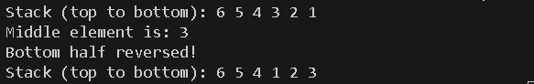
1. Output from the given code.
3. Queue Problem: Implement a queue using arrays (not STL) that: (20 marks)
1. Has basic enqueue and dequeue operations
2. Has a function to reverse first K elements
3. Has a function to interleave first half with second half
4. Handle queue overflow/underflow
#include <iostream>
using namespace std;
class Queue {
private:
int arr[10];
int frnt;
int back;
int count;
public:
Queue() {
frnt = 0;
back = -1;
count = 0;
}
bool isFull() {
return count == 10;
}
bool isEmpty() {
return count == 0;
}
void enqueue(int value) {
if (isFull()) {
cout << "Queue Overflow!\n";
} else {
back = (back + 1) % 10;
arr[back] = value;
count++;
}
}
void dequeue() {
if (isEmpty()) {
cout << "Queue Underflow!\n";
} else {
frnt = (frnt + 1) % 10;
count--;
}
}
void display() {
if (isEmpty()) {
cout << "Queue is empty!\n";
return;
}

cout << "Queue (front to rear): ";
for (int i = 0; i < count; i++) {
int index = (frnt + i) % 10;
cout << arr[index] << " ";
}
cout << endl;
}
void reverseFirstK(int k) {
if (k > count || k <= 0) {
cout << "Invalid K!\n";
return;
}
int tmp[10];
for (int i = 0; i < k; i++) {
tmp[i] = arr[(frnt + k - 1 - i) % 10];
}
for (int i = k; i < count; i++) {
tmp[i] = arr[(frnt + i) % 10];
}
for (int i = 0; i < count; i++) {
arr[(frnt + i) % 10] = tmp[i];
}

cout << "First " << k << " elements reversed!\n";
}
void interleaveQueue() {
if (count % 2 != 0) {
cout << "Need even number of elements to interleave!\n";
return;
}
int half = count / 2;
int tmp[10];
for (int i = 0; i < half; i++) {
tmp[i * 2] = arr[(frnt + i) % 10];
}

for (int i = 0; i < half; i++) {
tmp[i * 2 + 1] = arr[(frnt + half + i) % 10];
}
for (int i = 0; i < count; i++) {
arr[(frnt + i) % 10] = tmp[i];
}
cout << "Queue interleaved!\n";
}
};
int main() {
Queue q;
q.enqueue(10);
q.enqueue(20);
q.enqueue(30);
q.enqueue(40);
q.enqueue(50);
q.enqueue(60);
q.display();
q.reverseFirstK(3);
q.display();
q.interleaveQueue();
q.display();
return 0;
}
Output:
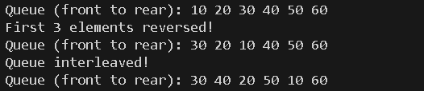
3. Output When user runs the code.

4. Linked List Problem: Create a singly linked list (not STL) that: (20 marks)
1. Has functions to insert at start/end/position
2. Has a function to detect and remove loops
3. Has a function to find nth node from end
4. Has a function to reverse list in groups of K nodes
#include <iostream>
using namespace std;
class Node {
public:
int data;
Node* next;
Node(int val) : data(val), next(nullptr) {}
};
class LinkedList {
private:
Node* head;
public:
LinkedList() : head(nullptr) {}
void insertAtStart(int val) {
Node* newNode = new Node(val);
newNode->next = head;
head = newNode;
}
void insertAtEnd(int val) {
Node* newNode = new Node(val);
if (!head) {
head = newNode;
return;
}

Node* current = head;
while (current->next) {
current = current->next;
}
current->next = newNode;
}
void insertAtPosition(int val, int pos) {
if (pos == 1) {
insertAtStart(val);
return;
}
Node* newNode = new Node(val);
Node* current = head;
for (int i = 1; i < pos-1 && current; i++) {
current = current->next;
}
if (!current) {
cout << "Invalid position!\n";
return;
}
newNode->next = current->next;
current->next = newNode;
}
void findNthFromEnd(int n) {
if (!head) {
cout << "List is empty!\n";
return;
}
Node* first = head;
Node* second = head;
for (int i = 0; i < n; i++) {
if (!first) {
cout << "List is too short!\n";
return;
}
first = first->next;
}
while (first) {
first = first->next;
second = second->next;
}

cout << n << "th node from end: " << second->data << endl;
}
void reverseGroups(int k) {
head = reverseGroupHelper(head, k);
}
Node* reverseGroupHelper(Node* node, int k) {
Node* current = node;
Node* prev = nullptr;
Node* next = nullptr;
int count = 0;
while (current && count < k) {
next = current->next;
current->next = prev;
prev = current;
current = next;
count++;
}
if (next) {
node->next = reverseGroupHelper(next, k);
}
return prev;
}
void detectAndRemoveLoop() {
if (!head || !head->next) {
cout << "No loop found.\n";
return;
}
Node* slow = head;
Node* fast = head;
while (fast && fast->next) {
slow = slow->next;
fast = fast->next->next;
if (slow == fast) {
removeLoop(slow);
cout << "Loop found and removed.\n";
return;
}
}

cout << "No loop found.\n";
}
void removeLoop(Node* loopNode) {
Node* ptr1 = head;
Node* ptr2 = loopNode;
while (ptr1->next != ptr2->next) {
ptr1 = ptr1->next;
ptr2 = ptr2->next;
}
ptr2->next = nullptr;
}
void display() {
Node* current = head;
while (current) {
cout << current->data << " -> ";
current = current->next;
}
cout << "NULL\n";
}
};
int main() {
LinkedList list;
list.insertAtEnd(1);
list.insertAtEnd(2);
list.insertAtEnd(3);
list.insertAtStart(0);
list.insertAtPosition(10, 3);
cout << "Original list: ";
list.display();
cout << "2nd from end: ";
list.findNthFromEnd(2);
cout << "Reversing in groups of 2: ";
list.reverseGroups(2);
list.display();
cout << "Checking for loops: ";
list.detectAndRemoveLoop();
return 0;
}
Output:
